**Git Ignore**

1. Create a sample .log file



1. Create a log folder and put a file inside it

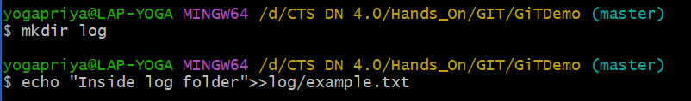

1. Create .gitignore file and open it in notepad++

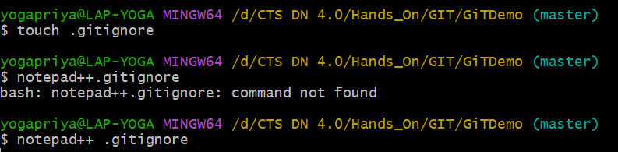

1. Add these lines, save and close the editor

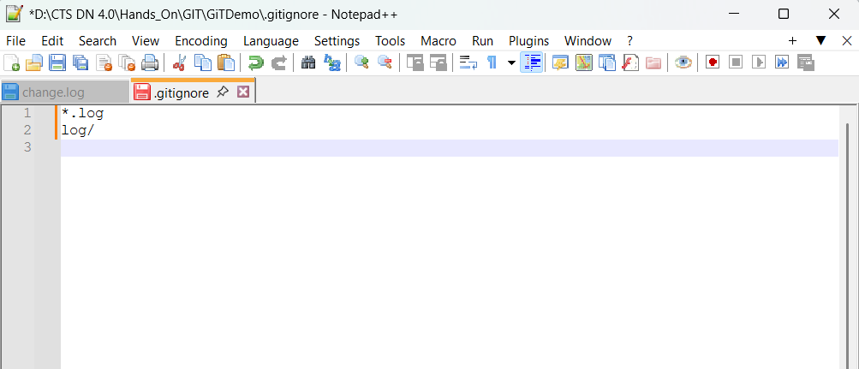

*.log → ignore all files ending in .log

log/ → ignore the entire log folder

1. When we run git status, we should not see debug.log or the log folder listed as untracked files as they will be skipped

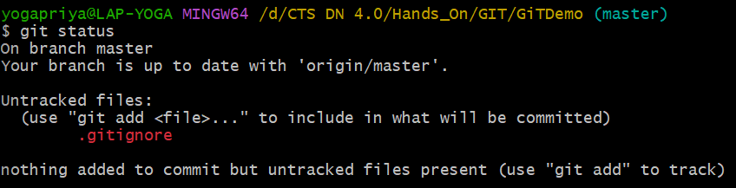

1. Commit the .gitignore change

